Realization document

TruePartner

By: Simeon Markov
Institution: Fontys UAS
Course: IN-SDE4
Date: 2026-04-01

Introduction
This document highlights the development phase of the project, detailing the technical aspects and development approach. It includes a documentation of the codebase, core logic, components of the architecture and comparison between initial design and final product.

System architecture
Architecture: Three-layer architecture (Razor pages – Server-side rendering).
Back-end: C# responsible for handling core logic (repositories, services, routing, business data).
Front-end: HTML for document’s structure, CSS & Bootstrap for styling (project’s views).
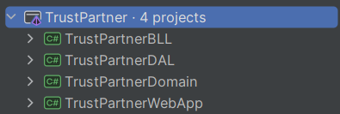
Figure 1: Snippet of project’s three-layer architecture

Design vs Realisation phase

UI Additions
………….

Code documentation
Main logic:
DAL (Data-Access layer): All operations related to storing, retrieving and any sort of manipulations are performed in that layer through repositories, which contain the actual implementation. No ORMs are used, but rather raw SQL queries are executed, allowing more flexibility on data access level.
Domain: This layer contains the business data, the system is working with. The DAL layer reads from the core data of the system.
BLL (Business logic layer): This layer presents the logic, behaviour of the system. By implementing one or more interfaces, each service could take different implementations (possible due to multi inheritance and dependency injection).
App: This layer presents the front-end of the system (razor pages).

Development methodology and techniques

Conclusion

